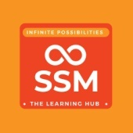

**SSM Institute of Engineering and Technology**

**NDLI Club of SSMIET - Library**

**Quiz on Tamil GK 18-11-2022**

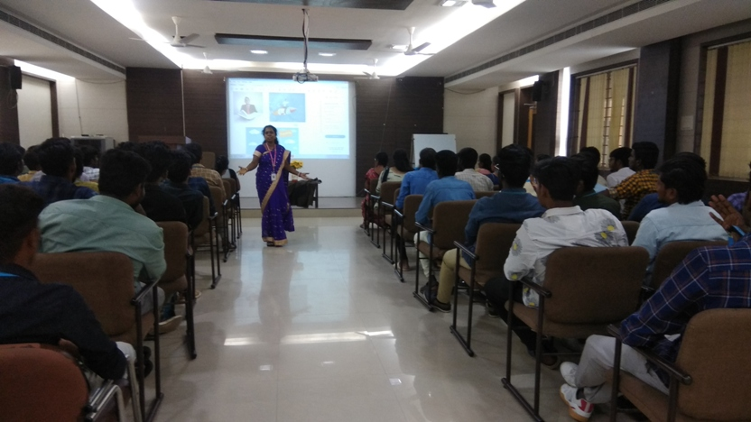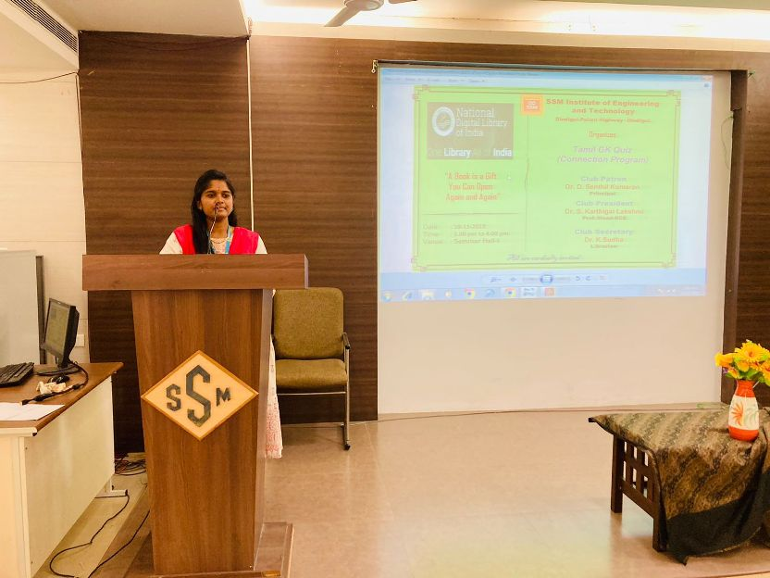**SSMIET – NDL Club** conducted the Quiz program on Tamil General Knowledge on 18th November 2022. The aim of this programme is to make the students more familiar with the Tamil Culture, Tamil Proverbs, Thirukkural and Tamil Writers etc. This programme was started with the video clippings of quiz questions by the Librarian of the college Dr. K.Sudha (NDL Club Secretary). Overall the event was an informative and interesting one. Students are eagerly involved in this competition and register their answers with hopeful and enjoyable.

